- The year value should use a capital 'Y', the '%' symbol should be shown larger, and 'mo' should be spelled out as 'months'.
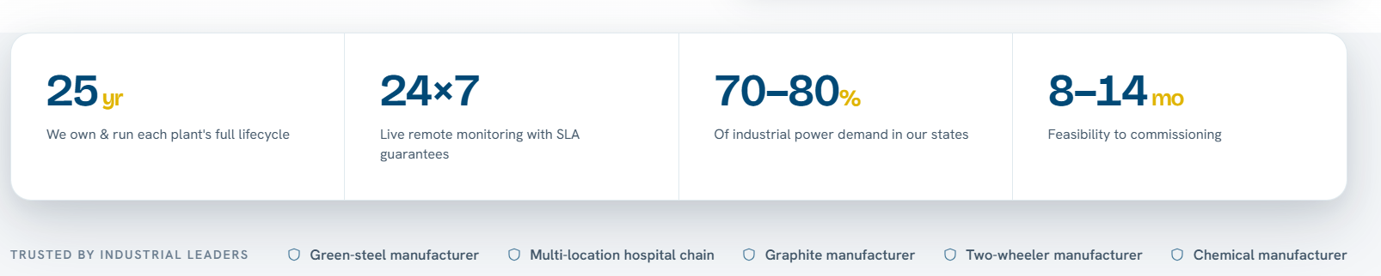
- Replace “Green Steel Manufacture” with “Midsize Steel Manufacture”.
- Start here can be removed.
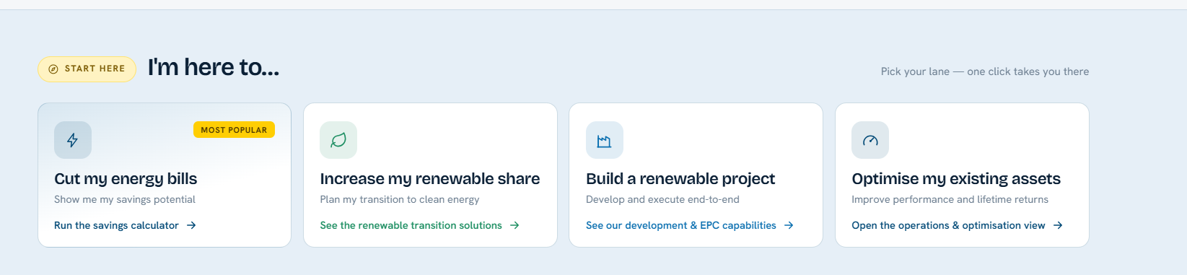
- The dark-blue hover effect used across all content blocks should instead match each section's own colour tile. Separately, blue is used in three places — consider changing it to a different colour.
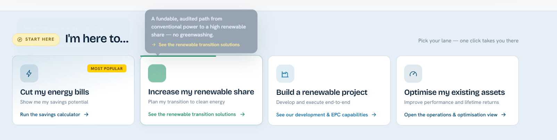
- “Design the Right Mix” should be clickable and link to the Wind + Solar + BESS section. “Structure & Deliver the Project” should link to the SPARK framework's “A” step. “Decarbonise” should link to the BTM (Behind-the-Meter) section, and “Operate & Optimise” should link to the SPARK framework's “K” step.
- The tagline “One accountable partner across the energy lifecycle” should be centre-aligned.

- SPARK one liner.

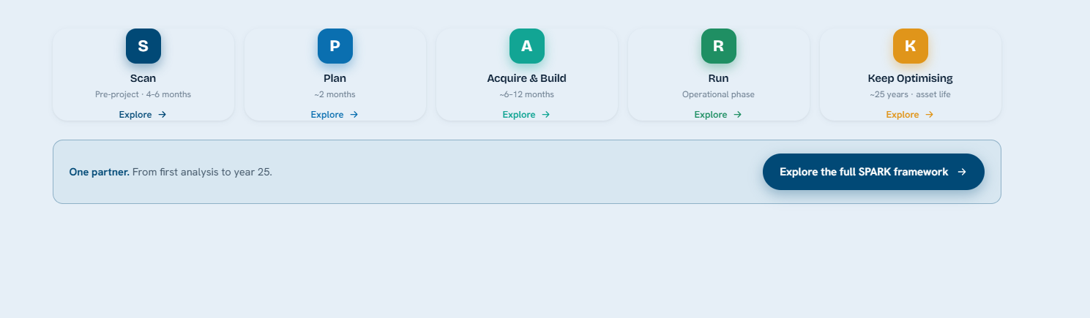

S -
P -
A -
R -
K –

- The overall SPARK framework should appear within the Platform section, rather than under “How We Partner”.
- The shield icon repeats in multiple places across the site — consider replacing it with a different icon.

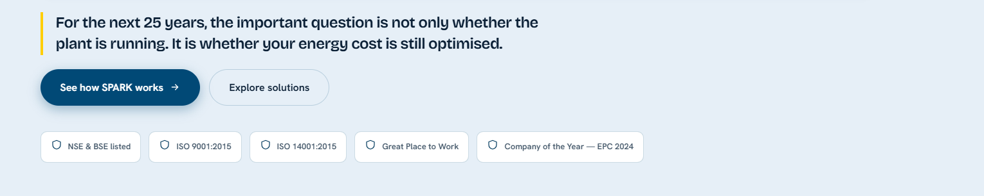
- Remove the “BSE & NSE Listed” mention. Add the GPWT logo as a small icon in the top right, near the main logo. This whole section can be taken down.
- There is excess white space between sections in several places on the home page — this should be tightened up.
- Add the company's actual CIN (Corporate Identification Number) to the site - U40106KA2021PLC144691.
- Reuse the Privacy Policy, Terms & Conditions, and Disclaimer content from the existing website.
- Show only the LinkedIn link, since we're not actively using Instagram or X (Twitter).
- Keep the existing awards/journal content as is, along with its images — otherwise, I will share new images for the awards section.
- Under the solution tab, we can remove the case study.
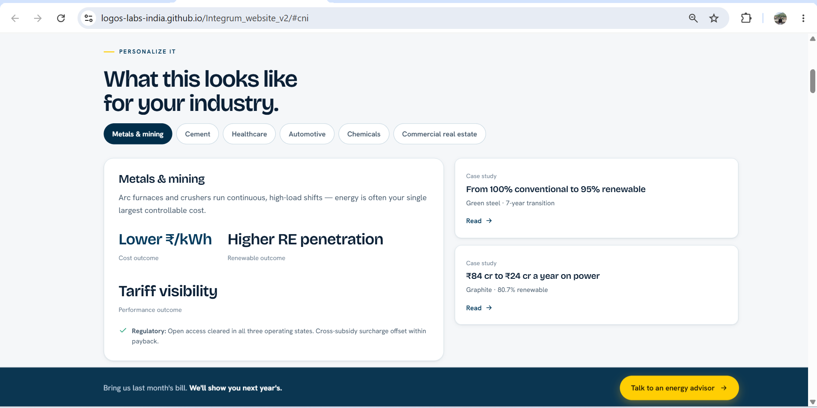
- For all images used on the site, source them from Pexels, use non-copyrighted images, or use AI-generated images.
- “RE Transition” is currently numbered “01” — change it to “02”.
- Remove “Inside 01” and instead add a clickable link above that takes users to this section directly. The content feels repeated — it should be moved up rather than duplicated.

- This can be removed as we are anyway gonna keep the below small tab.
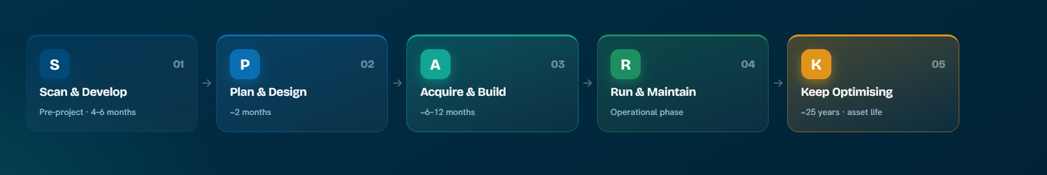
- The images used for “Plan & Design” and “Acquire & Build” should be replaced, as the current ones aren't suitable for Integrum.
- There's a large empty space that makes it look like an animation or video is still loading — this should be fixed.
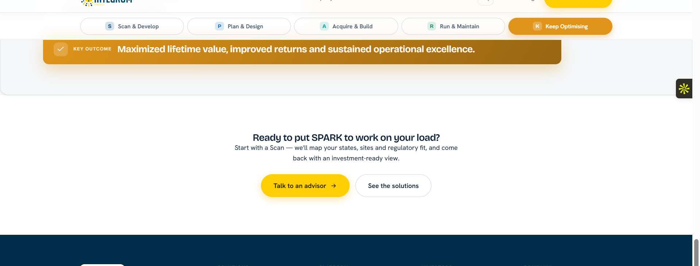

- This section can be removed.
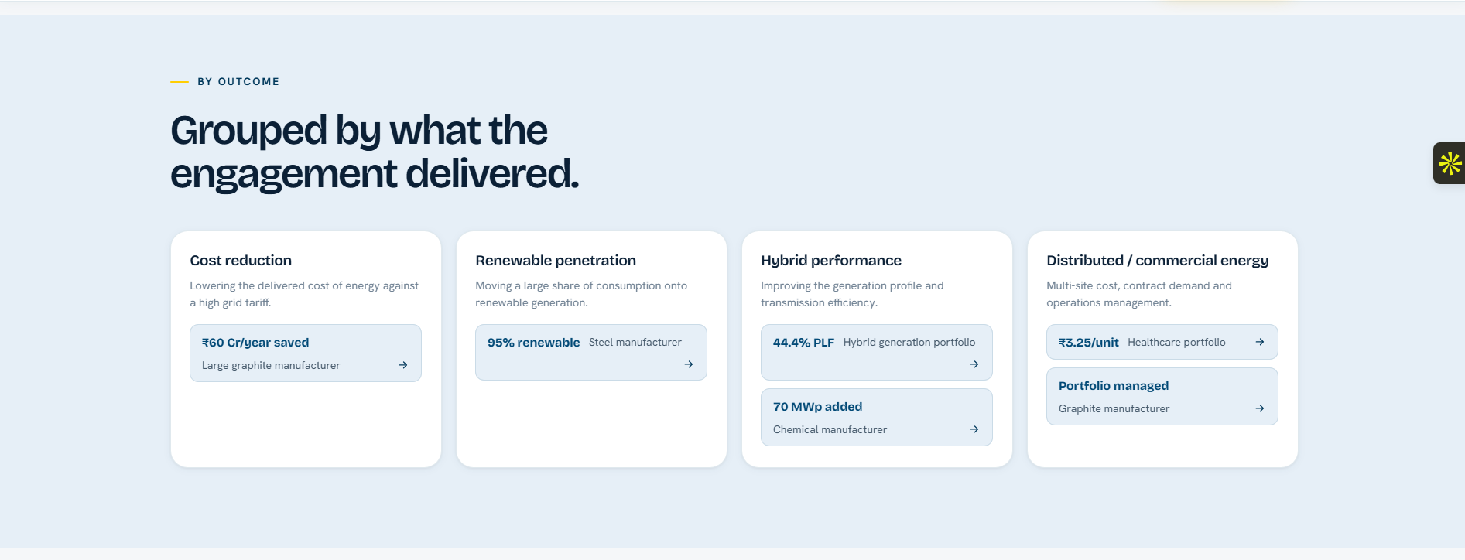

- Update the copy to: “Integrum is building as an energy platform for businesses.”
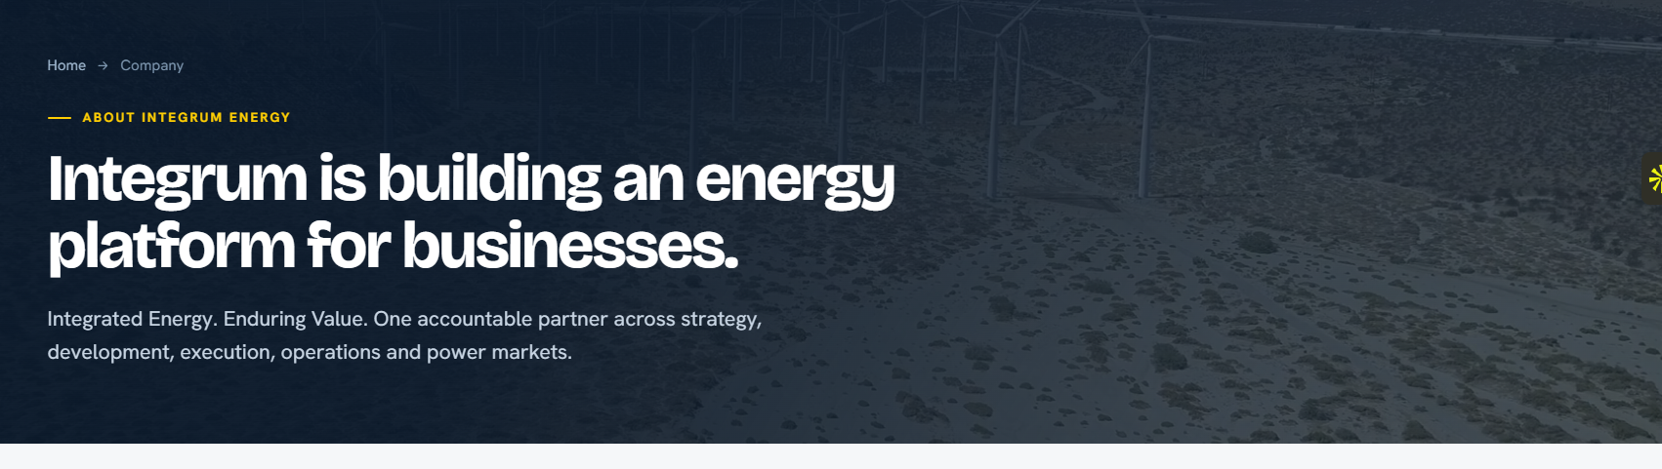
- Remove this entire section under the Company tab and replace it with the Awards and Blogs content from the previous website, since this section duplicates existing content.
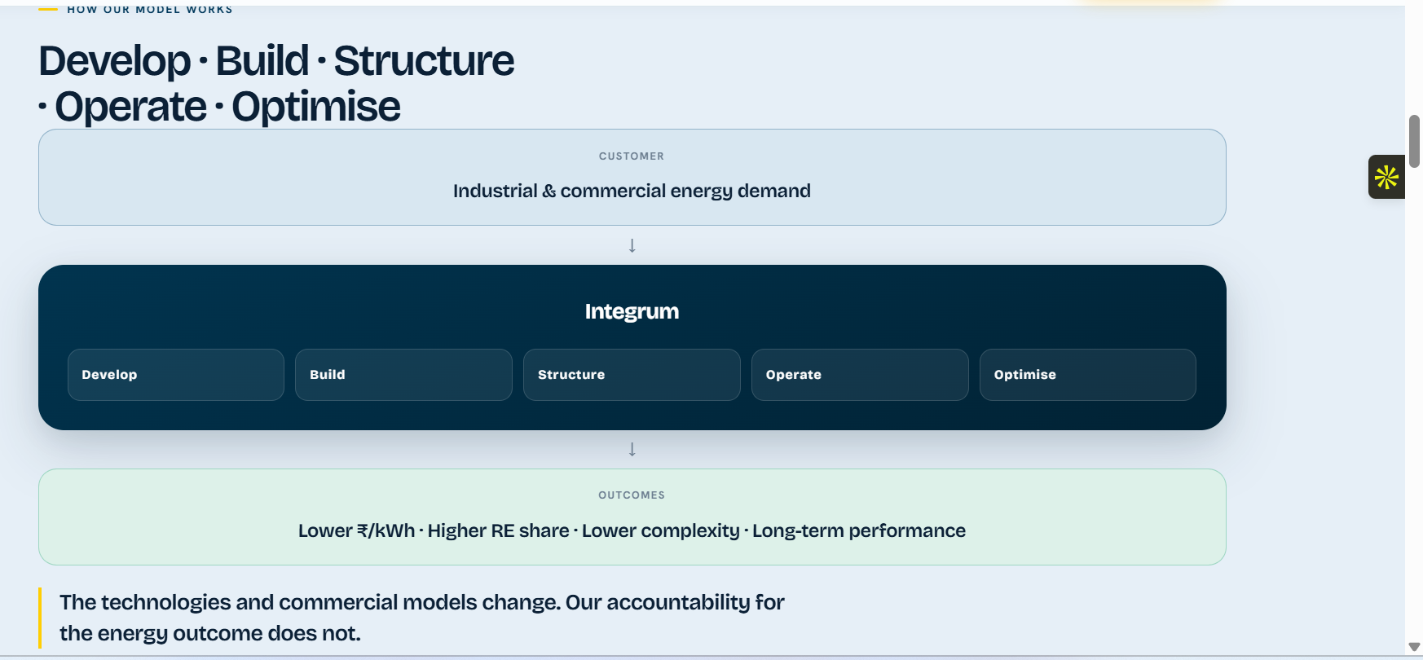
- We need to decide how we plan to source/display this data — otherwise it should be removed.
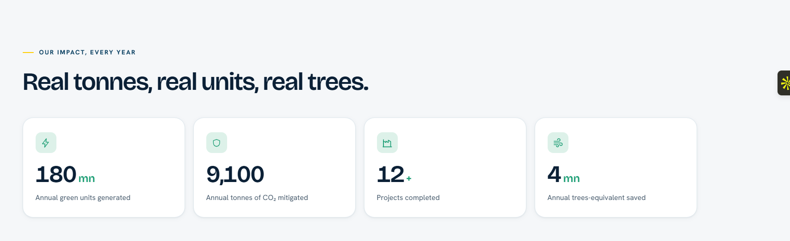
- On the Company page, change the CTA (call-to-action) button's hover colour.
- The “Meet the Team” link currently goes to the Company tab instead of the Leadership page — it should point to Leadership.
- We can give an option for others inside the selector/list. The colours can be similar to other website theme.
